**Lab practical 01**

**COA**

**Question:**

**Write an assembly language program to print your name.**

**Code:**

**org 100h**

**jmp start**

**msg: db "Srija", 0Dh,0Ah, 24h**

**start: mov dx, msg**

**mov ah, 09h**

**int 21h**

**mov ah, 0**

**int 16h**

**ret**

**OUTPUT:**

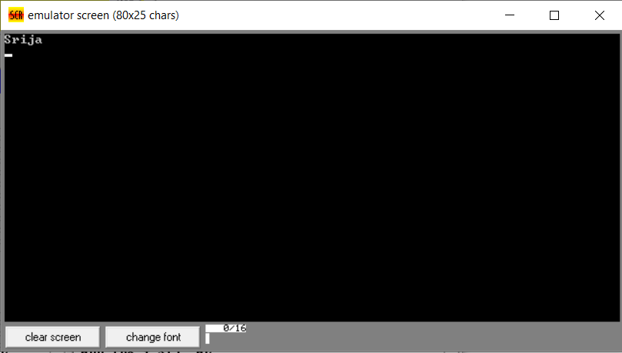

**Question:**

**Write a program in assembly language to print “Hello World”.**

**CODE:**

**org 100h**

**jmp start**

**msg: db "Hello World!", 0Dh,0Ah, 24h**

**start: mov dx, msg**

**mov ah, 09h**

**int 21h**

**mov ah, 0**

**int 16h**

**ret**

**OUTPUT:**

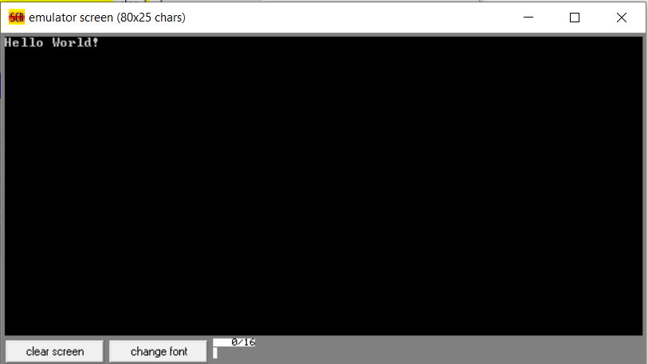

**GITHUB:**